PowerMatcher i3

PowerMatcher as a Service Architecture and Design

Authors: Aldo Eisma (IBM)
Release: 0.5




Document version: 1
Date: 4-9-2012

Table of Contents
1. Introduction 6
1.1 The PowerMatcher concept 6
1.2 PowerMatcher Foundation versus PowerMatcher as a Service 6
1.3 Scope of this document 7
2. Architecture and Design of PowerMatcher as a Service 7
2.1 System Context 7
2.2 Subsystems and dependencies in PowerMatcher as a Service 8
2.3 PowerMatcher Foundation subsystem 9
2.4 Messaging Bus subsystem 9
2.4.1 IBM WebSphere MQ and MQ Telemetry Transport 10
2.5 Data Collection subsystem 11
2.5.1 Data Collection subsystem component model 11
2.5.2 Data Collection subsystem deployment model 25
2.6 Business Intelligence subsystem 27
2.6.1 Business Intelligence subsystem component model 27
2.6.2 Business Intelligence subsystem deployment model 28
2.7 Provisioning subsystem 29
2.7.1 Provisioning subsystem component model 29
2.7.2 Provisioning subsystem deployment model 32
2.7.3 Distributed deployment topology 33
2.7.4 Test deployment topology 34
3. References 35

Table of Figures
Figure 1 - PowerMatcher Foundation versus PowerMatcher as a Service 6
Figure 2 - System Context 7
Figure 3 – PowerMatcher as a Service System Model 8
Figure 4 - PowerMatcher Foundation subsystem 9
Figure 5 -- Agents, Adapters and the Messaging Bus 10
Figure 6 - MQ Telemetry Transport 10
Figure 7 - Data Collection subsystem 11
Figure 8 - PowerMatcher Event Data Capture data model table 12
Figure 9 - Telemetry Data Capture model 14
Figure 10 - Telemetry Meta Data model 21
Figure 11 - Data Collection deployment 25
Figure 12 - Data Collection deployment example 26
Figure 13 - Business Intelligence subsystem 27
Figure 14 - Content Manager deployment 28
Figure 15 - Data Manager deployment 28
Figure 16 - Data Manager deployment example 29
Figure 17 - Provisioning subsystem 29
Figure 18 - Configuration Data Model 30
Figure 19 - Provisioning deployment 32
Figure 20 - Distributed Deployment Topology 33
Figure 20 - Test Deployment Topology 34

Table of Tables
Table 1 – PWMEVENT.MarketBasisData table 13
Table 2 - PWMEVENT.PriceData table 13
Table 3 - PWMEVENT.BidData table 14
Table 4 - CPSS.AlertData table 15
Table 5 - CPSS.ControlData table 15
Table 6 - CPSS.MeasurementData table 16
Table 7 - CPSS.RequestResponseData table 16
Table 8 - CPSS.StatusData table 17
Table 9 - CPSS.TopologyData table 18
Table 10 - CPSS.InstalledEquipment table 18
Table 11 - CPSS.InstalledEquipmentRel table 19
Table 12 - CPSS.MonitoringData table 19
Table 13 - CPSS.MonitoringStatus view 20
Table 14 - CPSS.AgentEquipmentRel table 20
Table 15 - CPSSMETA.EquipmentType table 21
Table 16 - CPSSMETA.EquipmentTypeAttribute table 22
Table 17 - CPSSMETA.EquipmentAttributeType table 22
Table 18 - CPSSMETA.EquipmentAttribute table 22
Table 19 - CPSSMETA.LocationType table 23
Table 20 - CPSSMETA.LocationTypeAttribute table 23
Table 21 - CPSSMETA.Location table 23
Table 22 - CPSSMETA.LocationAttributeType table 23
Table 23 - CPSSMETA.LocationAttribute table 24
Table 24 - CPSSMETA.ControlType table 24
Table 25 - CPSSMETA.MeasurementType table 24
Table 26 - CPSSMETA.StatusType table 25
Table 27 - CONFMGR.Configuration table 30
Table 28 - CONFMGR.Property table 30
Table 29 - CONFMGR.NodeConfiguration table 31
Table 30 - CONFMGR.NodeConfiguration_Configuration table 31
Table 31 - CONFMGR.Authorization table 31

Version History

Version | Description | Author
1 | PowerMatcher release version 0.5 | A.H. Eisma (IBM)

Introduction

The PowerMatcher concept
The PowerMatcher concept is based on the micro-economic principle of demand and supply.
Supply and demand is one of the most fundamental concepts of economics and it is the backbone of a market economy. Demand refers to how much (quantity) of a product or service is desired by buyers. The quantity demanded is the amount of a product people are willing to buy at a certain price; the relationship between price and quantity demanded is known as the demand relationship. Supply represents how much the market can offer. The quantity supplied refers to the amount of a certain good producers are willing to supply when receiving a certain price. The correlation between price and how much of a good or service is supplied to the market is known as the supply relationship. Price expresses the willingness to pay for supply and demand.
The relationship between demand and supply underlie the forces behind the allocation of resources. In market economy theories, demand and supply theory will allocate resources in the most efficient way possible.
When supply and demand are equal (i.e. when the supply function and demand function intersect) the economy is said to be at equilibrium.
The same mechanism is used in PowerMatcher. PowerMatcher core application provides the marketing mechanism for the determination of the equilibrium, while the agents work as actors representing demand and/or supply.

PowerMatcher Foundation versus PowerMatcher as a Service
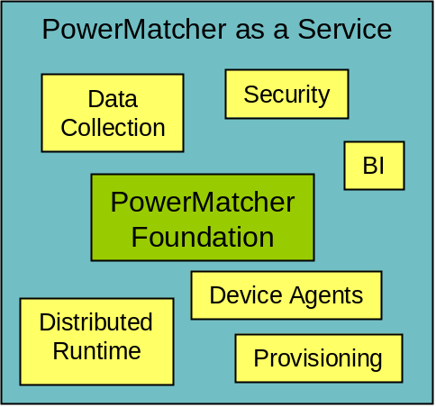
Figure 1 - PowerMatcher Foundation versus PowerMatcher as a Service
- PowerMatcher Foundation
  - A Java component model and framework for “plug & play”
PowerMatcher components.
  - Strict separation between PowerMatcher API and protocol layer.
  - Common PowerMatcher components like Auctioneer, Concentrator, etc.
  - Protocol adapter for MQ Telemetry messaging bus.

- PowerMatcher as a Service adds the following to the core
  - Centralized platform for managing multiple, independent, PowerMatcher clusters.
    - Dynamic provisioning: software & configuration updates for PowerMatcher clusters.
    - Data collection: logging PowerMatcher and telemetry data in a database.
  - Run-time platform for PowerMatcher clusters.
    - Centralized: Auctioneer and other agents running in the server environment.
    - Remote: Gateway for running concentrators and other agents on distributed sites.
  - Business Analytics for PowerMatcher clusters.
    - Reporting framework.
    - Core and sample reports.
  - Security, scalability, flexibility.
  - Project and device specific PowerMatcher components.

Scope of this document
This document covers the architecture and design of PowerMatcher as a Service. PowerMatcher Foundation can be deployed in different contexts, one of them being PowerMatcher as a Service. The design of PowerMatcher Foundation is covered in a separate document.

Architecture and Design of PowerMatcher as a Service

System Context
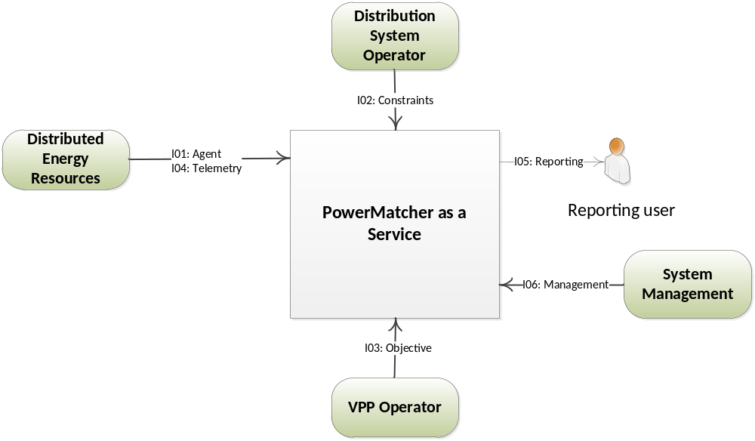
Figure 2 - System Context

Subsystems and dependencies in PowerMatcher as a Service
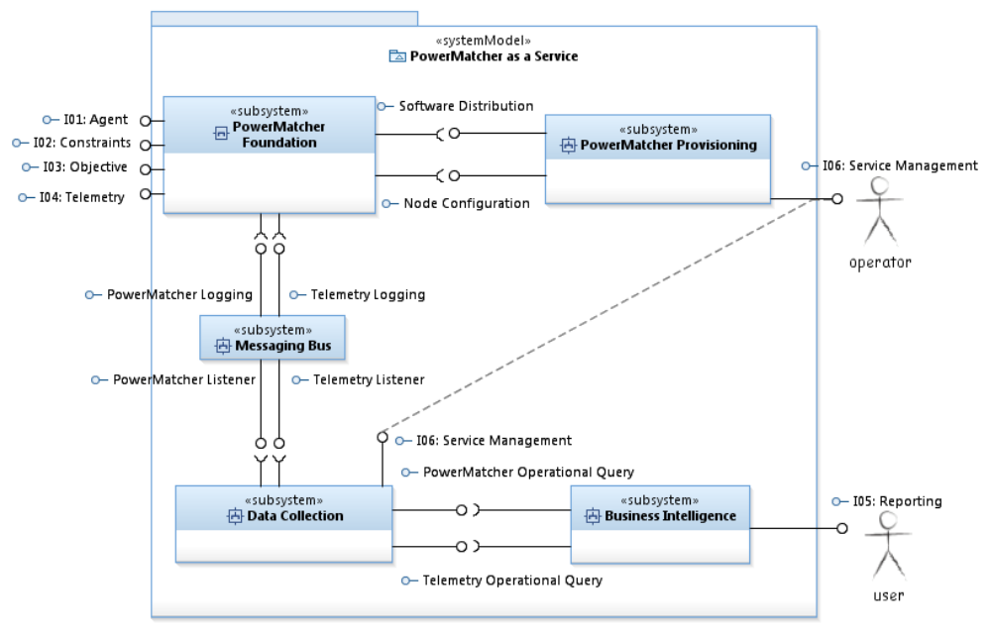
Figure 3 – PowerMatcher as a Service System Model
PowerMatcher as a Service adds support for provisioning, distributed deployment in combination with centralized data collection, and business intelligence on top of PowerMatcher Foundation. This is depicted in the above subsystem diagram. Each of the subsystems is further broken down in the following sections.

PowerMatcher Foundation subsystem
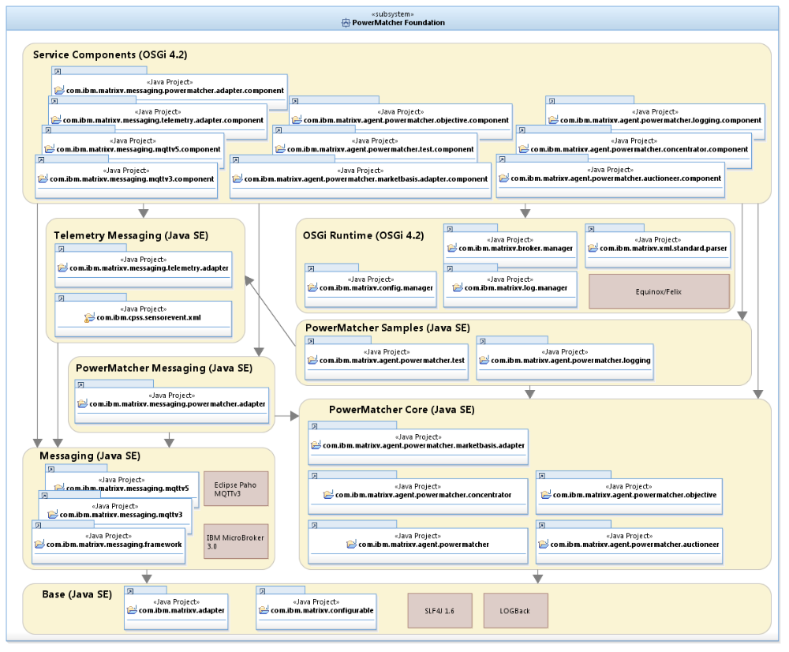
Figure 4 - PowerMatcher Foundation subsystem

Messaging Bus subsystem
PowerMatcher, telemetry and other messages are exchanged via a message bus. The message bus is there to facilitate n-m publish/subscribe messaging in a structured way. A publish/subscribe message bus supports loosely coupled components in the following way:
- A producer can publish messages on the bus on a named topic.
- When a message is published, it is delivered to all consumers that subscribe to that topic. There can be zero or more subscribers for a topic.
- A subscriber can subscribe to multiple topics through wildcards.
- Messages are not queued; a subscriber will not receive matching messages published before the subscription was made.
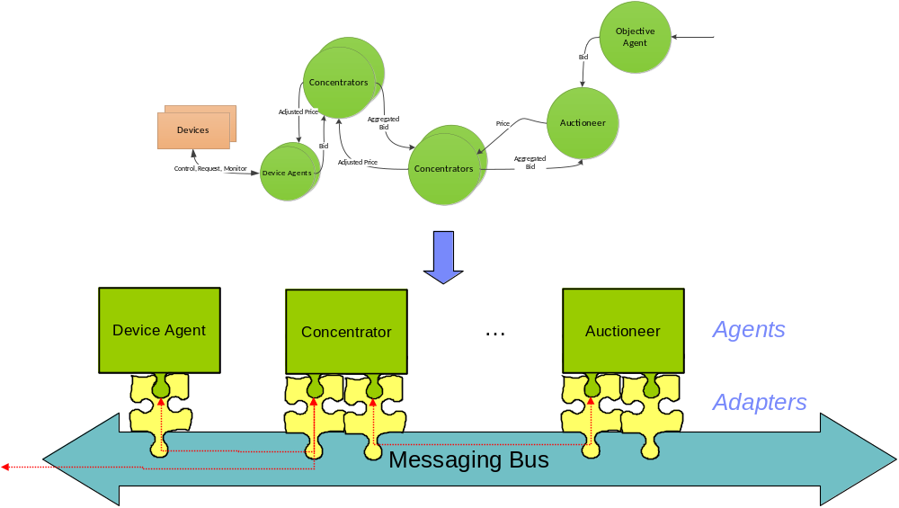
Figure 5 -- Agents, Adapters and the Messaging Bus

IBM WebSphere MQ and MQ Telemetry Transport
The messaging transport supported in this release is the MQ Telemetry publish/subscribe protocol, enabling distributed components residing on different locations with low bandwidth and processing power. The MQTT messages are transported over the TCP/IP network protocol, either in the plain for internal connections, or over SSL/TLS over the Internet. Agents connected to a MQ Telemetry broker act as MQTT-clients.

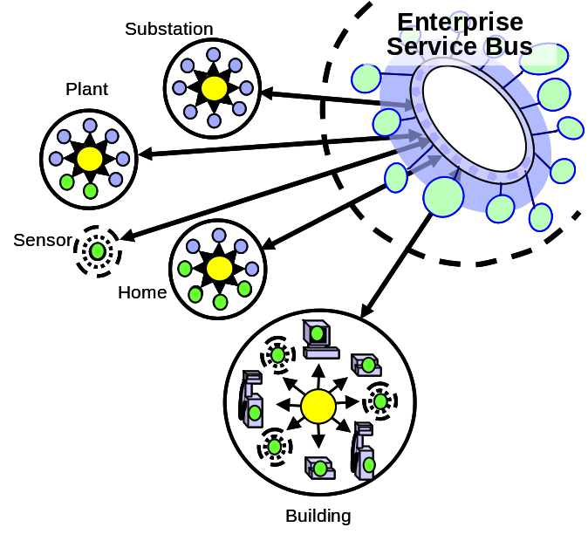
Figure 6 - MQ Telemetry Transport
- MQTT is a machine-to-machine and "Internet of Things“
connectivity protocol. It was designed as an extremely
lightweight publish/subscribe messaging transport by Arcom and IBM.
  - The MQTT protocol is public with a royalty-free license.
See http://mqtt.org
  - Various open source client and broker implementations exist.
  - IBM ships commercial implementations, ranging from single device to highly scalable enterprise broker.
- Separate adapters for telemetry data collection, project specific interfaces, etc.

Currently popular languages (Java, C/C++, C#/.NET) and platforms are supported. Examples of commercial MQTT-client software implementations are:
- The redistributable Java and C clients supplied with IBM WebSphere MQ^{[1]}.
- The MQTTv5 client and Micro Broker supplied with IBM Lotus Expeditor, which provides C, Java and .NET API’s. MicroBroker supports bridging between MQTT brokers.
- The open-source Eclipse Paho C and Java MQTT client connects to, but does not include, a broker. Can connect to Mosquito, MicroBroker, WebSphere MQ, and other brokers that implement the MQTTv3 standard.

Data Collection subsystem

Data Collection subsystem component model
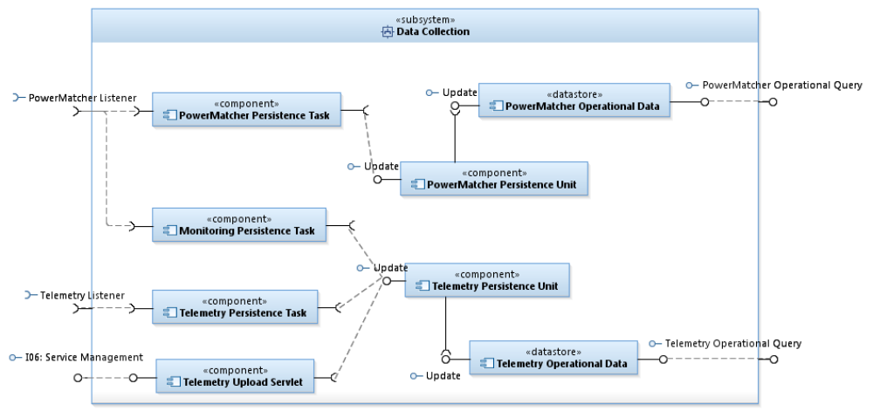
Figure 7 - Data Collection subsystem
The Data Collection subsystem is responsible for capturing PowerMatcher logging events and Telemetry events from the message bus and persist these events in the operational data stores. The following subsections describe the Data Collection subsystem in more detail.

PowerMatcher Operational Data datastore
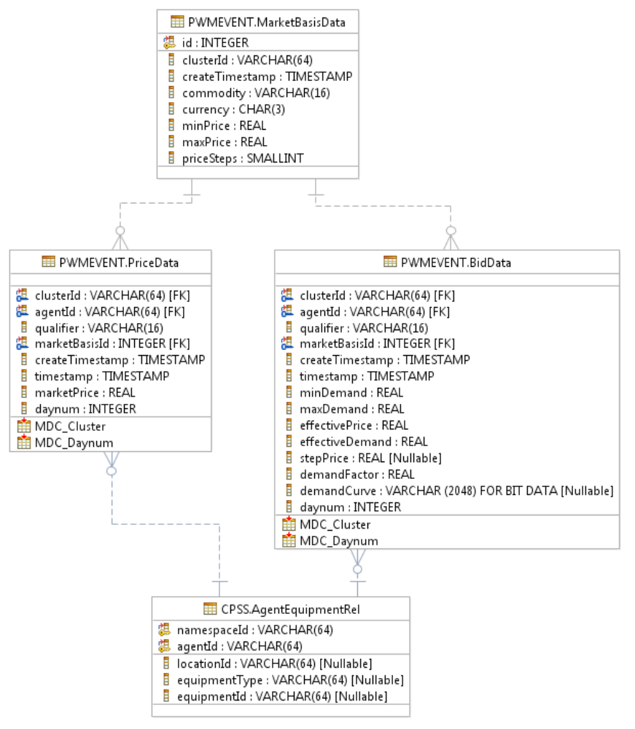
Figure 8 - PowerMatcher Event Data Capture data model table

PWMEVENT.MarketBasisData table
PowerMatcher MarketBasis data associated with Price or Bid events.
Column | Description
id | Generated unique identity for the MarketBasis row.
clusterId | ID of the PowerMatcher cluster.
createTimestamp | Timestamp when the row was created. The timestamp is in local time.
commodity | Commodity for the market basis, for example "electricity".
currency | 3 character international currency code, for example "EUR".
minPrice | Minimum price defined for this market basis.
maxPrice | Maximum price defined for this market basis.
priceSteps | Number of price steps between minimum and maximum price.
Table 1 – PWMEVENT.MarketBasisData table

PWMEVENT.PriceData table
PowerMatcher Price event data.
Column | Description
clusterId | ID of the PowerMatcher cluster.
agentId | ID of the agent that is the receiving the price, or the matcher that is sending the price, depending on qualifier.  The agent ID is unique within the cluster.
qualifier | Role associated with the price event, for example "agent" or "matcher".
marketBasisId | The identity of the MarketBasis row associated with this Bid.
createTimestamp | Timestamp when the row was created. The timestamp is in local time.
timestamp | Source timestamp for the event, in UTC.
marketPrice | The market price for the event.
daynum | Generated column for multi-dimensional clustering by day number (YYYYMMDD) of createTimestamp.
Table 2 - PWMEVENT.PriceData table

PWMEVENT.BidData table
PowerMatcher Bid event data.
Column | Description
clusterId | ID of the PowerMatcher cluster.
agentId | ID of the agent that is sending the bid, or the matcher that is aggregating the bid, depending on qualifier.  The agent ID is unique within the cluster.
qualifier | Role associated with the bid, for example "agent" or "matcher".
marketBasisId | The identity of the MarketBasis row associated with this Bid.
createTimestamp | Timestamp when the row was created. The timestamp is in local time.
timestamp | Source timestamp for the event, in UTC.
minDemand | Minimum demand (demand at maximum price) in the bid curve.
maxDemand | Maximum demand (demand at minimum price) in the bid curve.
effectivePrice | Market price in effect at the time of bid, as received by the agent.
effectiveDemand | Demand at effectivePrice for the bid curve of this event.
stepPrice | If the bid curve can be represented as a single step from maxDemand to minDemand, this column represents the step price.  If stepPrice is null, the bid curve has multiple steps and cannot be represented as a single step.
demandFactor | The demand multiplication factor for the small integers in the demandCurve vector.
demandCurve | A vector of small integers (one for each price step) in big endian order (most significant byte first) representing the bid curve.  Each value is multiplied by demandFactor to obtain the actual demand for the step in the bid curve.
daynum | Generated column for multi-dimensional clustering by day number (YYYYMMDD) of createTimestamp.
Table 3 - PWMEVENT.BidData table

PowerMatcher Persistence Unit component
The PowerMatcher Persistence Unit is the Java Persistence Architecture Java EE component to access the PowerMatcher Operational Data datastore.

PowerMatcher Persistence Task component
The PowerMatcher Persistence Task is the Java EE Message Driven Bean that persists the PowerMatcher logging events received from the message bus via the persistence unit.

Monitoring Persistence Task component
The Monitoring Persistence Task is the Java EE Message Driven Bean that persists the PowerMatcher monitoring events received from the message bus using JDBC.

Telemetry Operational Data datastore
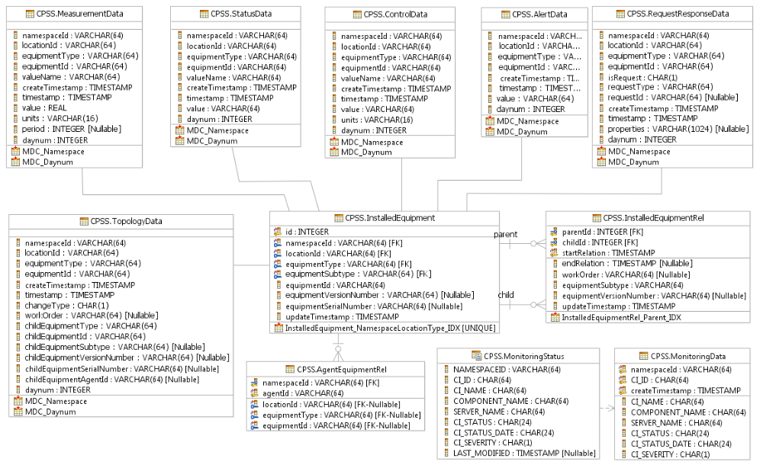
Figure 9 - Telemetry Data Capture model

CPSS.AlertData table
Data for an Alert event. An alert event represents an alarm or notification signalled by a piece of equipment.
Column | Description
namespaceId | The namespace that is the parent of the locations and equipment.
locationId | The logical or physical location of the equipment.  The location ID is unique within the namespace.
equipmentType | The type of the equipment.  The combination of equipmentType and equipmentId uniquely identify the equipment within the location.
equipmentId | The ID of the equipment.  The combination of equipmentType and equipmentId uniquely identify the equipment within the location.
createTimestamp | Timestamp when the row was created. The timestamp is in local time.
timestamp | Source timestamp for the event, in UTC.
value | The alert or notification message.
daynum | Generated column for multi-dimensional clustering by day number (YYYYMMDD) of createTimestamp.
Table 4 - CPSS.AlertData table

CPSS.ControlData table
Data for a Control event. A control event is a control message with a setting sent to a piece of equipment.
Column | Description
namespaceId | The namespace that is the parent of the locations and equipment.
locationId | The logical or physical location of the equipment.  The location ID is unique within the namespace.
equipmentType | The type of the equipment.  The combination of equipmentType and equipmentId uniquely identify the equipment within the location.
equipmentId | The ID of the equipment.  The combination of equipmentType and equipmentId uniquely identify the equipment within the location.
valueName | The ID of the control point of which the setting is changed.
createTimestamp | Timestamp when the row was created. The timestamp is in local time.
timestamp | Source timestamp for the event, in UTC.
value | The new value for the control property.
units | The unit (for example "C") for the control setting.  This is a copy of the unit defined in the associated ControlType.
daynum | Generated column for multi-dimensional clustering by day number (YYYYMMDD) of createTimestamp.
Table 5 - CPSS.ControlData table

CPSS.MeasurementData table
Data for a Measurement event. A measurement event represents an status change for one of the measurement values of a piece of equipment.
Column | Description
namespaceId | The namespace that is the parent of the locations and equipment.
locationId | The logical or physical location of the equipment.  The location ID is unique within the namespace.
equipmentType | The type of the equipment.  The combination of equipmentType and equipmentId uniquely identify the equipment within the location.
equipmentId | The ID of the equipment.  The combination of equipmentType and equipmentId uniquely identify the equipment within the location.
valueName | The ID of the measurement point for which the value has changed.
createTimestamp | Timestamp when the row was created. The timestamp is in local time.
timestamp | Source timestamp for the event, in UTC.
value | The new value for the measurement property.
units | The unit (for example "W") for the measurement.  This is a copy of the unit defined in the associated MeasurementType.
period | The (optional) period a quantitative measurement relates to, in seconds from source timestamp.
daynum | Generated column for multi-dimensional clustering by day number (YYYYMMDD) of createTimestamp.
Table 6 - CPSS.MeasurementData table

CPSS.RequestResponseData table
Data for a Request or Response event. A request event is a request message with parameters sent to a piece of equipment. A response event is a response message with paremeters received from a piece of equipment.
Column | Description
namespaceId | The namespace that is the parent of the locations and equipment.
locationId | The logical or physical location of the equipment.  The location ID is unique within the namespace.
equipmentType | The type of the equipment.  The combination of equipmentType and equipmentId uniquely identify the equipment within the location.
equipmentId | The ID of the equipment.  The combination of equipmentType and equipmentId uniquely identify the equipment within the location.
isRequest | “T” if the event is for a request, “F” if the event is for a response.
requestType | ID for the type of request the request or response message relates to.
requestId | Optional ID for the request, intended for pairing requests and response.
createTimestamp | Timestamp when the row was created. The timestamp is in local time.
timestamp | Source timestamp for the event, in UTC.
properties | String representation of the name/value pairs of the request or response properties.
daynum | Generated column for multi-dimensional clustering by day number (YYYYMMDD) of createTimestamp.
Table 7 - CPSS.RequestResponseData table

CPSS.StatusData table
Data for a Status event. A status event represents a status change for one of the status values of a piece of equipment.
Column | Description
namespaceId | The namespace that is the parent of the locations and equipment.
locationId | The logical or physical location of the equipment.  The location ID is unique within the namespace.
equipmentType | The type of the equipment.  The combination of equipmentType and equipmentId uniquely identify the equipment within the location.
equipmentId | The ID of the equipment.  The combination of equipmentType and equipmentId uniquely identify the equipment within the location.
valueName | The ID of the status point for which the value has changed.
createTimestamp | Timestamp when the row was created. The timestamp is in local time.
timestamp | Source timestamp for the event, in UTC.
value | The new value for the status property.
daynum | Generated column for multi-dimensional clustering by day number (YYYYMMDD) of createTimestamp.
Table 8 - CPSS.StatusData table

CPSS.TopologyData table
Data for a Topology event. A topology event represents an update in the properties or relationships of a piece of equipment. The topology events result in updates to the InstalledEquipment, InstallledEquipmentRel and AgentEquipmentRel tables.
Column | Description
namespaceId | The namespace that is the parent of the locations and equipment.
locationId | The logical or physical location of the equipment.  The location ID is unique within the namespace.
equipmentType | The type of the equipment.  The combination of equipmentType and equipmentId uniquely identify the equipment within the location.
equipmentId | The ID of the equipment.  The combination of equipmentType and equipmentId uniquely identify the equipment within the location.
createTimestamp | Timestamp when the row was created. The timestamp is in local time.
timestamp | Source timestamp for the event, in UTC.
changeType | “a” if an add event, “d” if a delete event, “c” if an update event.
workOrder | The (optional) work order associated with the change in topology.
childEquipmentType | The equipment type of the child that is being added, changed or deleted.
childEquipmentId | The equipment ID of the child that is being added, changed or deleted.
childEquipmentSubtype | The (optional) equipment subtype of the child that is being added, changed or deleted.
childEquipmentVersionNumber | The (optional) equipment version number of the child that is being added, changed or deleted.
childEquipmentSerialNumber | The (optional) equipment serial number of the child that is being added, changed or deleted.
childEquipementAgentId | The (optional) unique ID of the control agent of thje equipment. The agented is unique within the namespace.
daynum | Generated column for multi-dimensional clustering by day number (YYYYMMDD) of createTimestamp.
Table 9 - CPSS.TopologyData table

CPSS.InstalledEquipment table
Equipment that is, or has been, installed and for which event data is captured.
Column | Description
id | The unique generated identity, used as foreign key from InstalledEquipmentRel.
namespaceId | The namespace that is the parent of the locations and equipment.
locationId | The logical or physical location of the equipment.  The location ID is unique within the namespace.
equipmentType | The type of the equipment.  The combination of equipmentType and equipmentId uniquely identify the equipment within the location.
equipmentId | The ID of the equipment.  The combination of equipmentType and equipmentId uniquely identify the equipment within the location.
equipmentSubtype | The subtype of the equipment.  The equipment type and subtype identify the make and model.
equipmentVersionNumber | The (optional) version number of the equipment.  When the version number is updated, the latest value is found here.  The history of version numbers is captured in InstalledEquipmentRel.
equipmentSerialNumber | The (optional) serial number of the equipment, in case the serial number is not used for the equipmentId.
updateTimestamp | Timestamp when the row was created or updated. The timestamp is in local time.
Table 10 - CPSS.InstalledEquipment table

CPSS.InstalledEquipmentRel table
Topological parent-child relationship between equipment within the namespace.
A new relationship is created whenever the topology changes or equipment properties subtype or version number change.
Column | Description
parentId | The parent equipment in the relationship.  For equipment that has no parent in the equipment topology in a namespace, parentId == childId.
childId | The child equipment in the relationship.
startRelation | The timestamp of the start of the relationship, in UTC.
endRelation | The timestamp of the start of the relationship, in UTC. The timestamp is null if the relationship is current.
workOrder | The (optional) work order associated with the change in topology.
equipmentSubtype | The subtype of the equipment.  The equipment type and subtype identify the make and model at the time of the relationship.
equipmentVersionNumber | The (optional) version number of the equipment at the time of the relationship.
updateTimestamp | Timestamp when the row was created or updated. The timestamp is in local time.
Table 11 - CPSS.InstalledEquipmentRel table

CPSS.MonitoringData table
Monitoring events from data processing services. This table contains the event history, the MonitoringStatus view returns the last status for each Configuration Item.
Column | Description
namespaceId | The namespace that is the parent of the locations and equipment.
CI_ID | Unique identification of the Configuration Item (component, application or application element) within the namespace.
createTimestamp | Timestamp when the row was created. The timestamp is in local time.
CI_NAME | Unique name of the component, application or application element.
COMPONENT_NAME | Component Name, used for filtering in monitoring tool.
SERVER_NAME | Fully qualified host name of the server where the Configuration Item is deployed.  Note: if the CI is deployed on a cluster, then the cluster address must be used.
CI_STATUS | This field contains the status of the component / application / application element.
CI_STATUS_DATE | Date and time when the status is reported by the Configuration Item (based on the time used by the configuration item).  Example (in UTC): 2012-04-11T14:45:11:222Z'
CI_SEVERITY | Severity code, used for monitoring event dispatching.  F (Fatal)  C (Critical)  W (Warning)  M (Minor)  I (Informational)
Table 12 - CPSS.MonitoringData table

CPSS.MonitoringStatus view
View on MonitoringData that returns the last status for each Configuration Item.
Column | Description
namespaceId | The namespace that is the parent of the locations and equipment.
CI_ID | Unique identification of the Configuration Item (component, application or application element) within the namespace.
CI_NAME | Unique name of the component, application or application element.
COMPONENT_NAME | Component Name, used for filtering in monitoring tool.
SERVER_NAME | Fully qualified host name of the server where the Configuration Item is deployed.  Note: if the CI is deployed on a cluster, then the cluster address must be used.
CI_STATUS | This field contains the status of the component / application / application element.
CI_STATUS_DATE | Date and time when the status is reported by the Configuration Item (based on the time used by the configuration item).  Example (in UTC): 2012-04-11T14:45:11:222Z'
CI_SEVERITY | Severity code, used for monitoring event dispatching.  F (Fatal)  C (Critical)  W (Warning)  M (Minor)  I (Informational)
LAST_MODIFIED | Automatically generated during insert of new status event.  Used for monitoring of regular Status updates.
Table 13 - CPSS.MonitoringStatus view

CPSS.AgentEquipmentRel table
Agent to equipment mapping.
Column | Description
namespaceId | The namespace that is the parent of the locations and equipment.
agentId | Unique ID of the agent within the cluster.
locationId | The logical or physical location of the equipment.  The location ID is unique within the namespace.
equipmentType | The type of the equipment.  The combination of equipmentType and equipmentId uniquely identify the equipment within the location.
equipmentId | The ID of the equipment.  The combination of equipmentType and equipmentId uniquely identify the equipment within the location.
Table 14 - CPSS.AgentEquipmentRel table

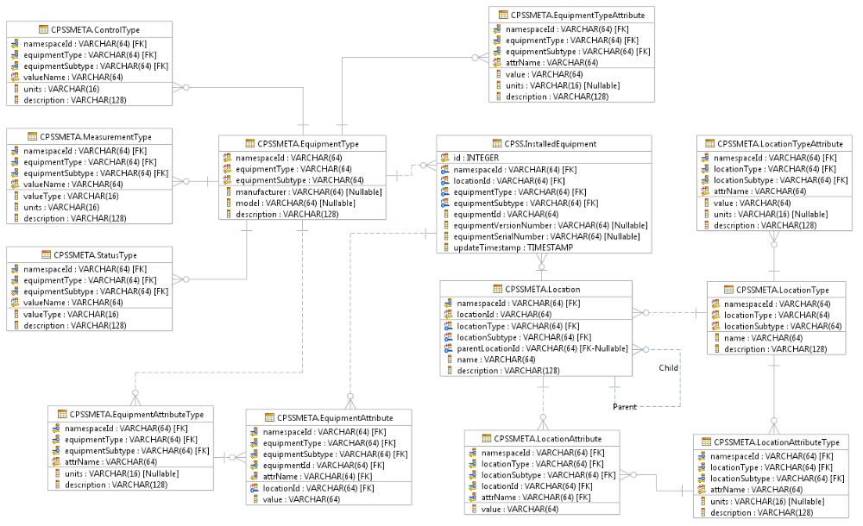
Figure 10 - Telemetry Meta Data model

CPSSMETA.EquipmentType table
EquipmentType defines a subtype of equipment by its key attributes.
Column | Description
namespaceId | The namespace that the locations and equipment belong to.
equipmentType | The equipment type.  The equipment type is unique within the namespace.
equipmentSubtype | The subtype of the equipment.  The equipment type and subtype identify the make and model.
manufacturer | The (optional) manufacturer of this equipment type.
model | The (optional) model of this equipment type.
description | A description of this type of equipment.
Table 15 - CPSSMETA.EquipmentType table

CPSSMETA.EquipmentTypeAttribute table
EquipmentTypeAttribute defines the characteristics for a particular subtype of equipment.
Column | Description
namespaceId | The namespace that the locations and equipment belong to.
equipmentType | The equipment type.  The equipment type is unique within the namespace.
equipmentSubtype | The subtype of the equipment.  The equipment type and subtype identify the make and model.
value | The value of the equipment type attribute.
units | The optional unit (for example "W") of the attribute value.
description | A description of this location.
Table 16 - CPSSMETA.EquipmentTypeAttribute table

CPSSMETA.EquipmentAttributeType table
EquipmentTypeAttribute defines the characteristics for a particular subtype of equipment.
Column | Description
namespaceId | The namespace that the locations and equipment belong to.
equipmentType | The equipment type.  The equipment type is unique within the namespace.
equipmentSubtype | The subtype of the equipment.  The equipment type and subtype identify the make and model.
attrName | The identifying name of the attribute defined for this equipment type.
units | The unit (for example "C") of the control setting.
description | A description of this equipment type attribute.
Table 17 - CPSSMETA.EquipmentAttributeType table

CPSSMETA.EquipmentAttribute table
EquipmentTypeAttribute defines the characteristics for a particular subtype of equipment.
Column | Description
namespaceId | The namespace that is the parent of the locations and equipment.
locationId | The logical or physical location of the equipment.  The location ID is unique within the namespace.
equipmentType | The type of the equipment.  The combination of equipmentType and equipmentId uniquely identify the equipment within the location.
equipmentSubtype | The subtype of the equipment.  The equipment type and subtype identify the make and model.
equipmentId | The ID of the equipment.  The combination of equipmentType and equipmentId uniquely identify the equipment within the location.
attrName | The identifying name of the attribute defined for this equipment type.
value | The value of the equipment attribute.
Table 18 - CPSSMETA.EquipmentAttribute table

CPSSMETA.LocationType table
LocationType defines the subtype of location by its key attributes.
Column | Description
namespaceId | The namespace that is the parent of the locations and equipment.
locationType | The location type.  The location type is unique within the namespace.
locationSubtype | The subtype of the location.  The location type and subtype classify the location.
name | Short descriptive name for this location type.
description | A description of this type of location.
Table 19 - CPSSMETA.LocationType table

CPSSMETA.LocationTypeAttribute table
LocationTypeAttribute defines the characteristics for a particular subtype of location.
Column | Description
namespaceId | The namespace that is the parent of the locations and equipment.
locationType | The location type.  The location type is unique within the namespace.
locationSubtype | The subtype of the location.  The location type and subtype classify the location.
attrName | The identifying name of the attribute defined for this location type.
value | The value of the location type attribute.
units | The optional unit (for example "m3") of the attribute value.
description | A description of this location type attribute.
Table 20 - CPSSMETA.LocationTypeAttribute table

CPSSMETA.Location table
Defines a physical or logical location where equipment is installed.
Column | Description
namespaceId | The namespace that is the parent of the locations and equipment.
locationId | The logical or physical location of the equipment.  The location ID is unique within the namespace.
locationType | The location type.  The location type is unique within the namespace.
locationSubtype | The subtype of the location.  The location type and subtype classify the location.
parentLocationId | The ID of the logical or physical location  The location ID is unique within the namespace.
name | Short descriptive name for this location.
description | A description of this location.
Table 21 - CPSSMETA.Location table

CPSSMETA.LocationAttributeType table
Defines the location-specific attributes for a location of a particular subtype.
Column | Description
namespaceId | The namespace that is the parent of the locations and equipment.
locationType | The location type.  The location type is unique within the namespace.
locationSubtype | The subtype of the location.  The location type and subtype classify the location.
attrName | The identifying name of the attribute defined for this location type.
units | The optional unit (for example "m3") of the attribute value.
description | A description of this location type attribute.
Table 22 - CPSSMETA.LocationAttributeType table

CPSSMETA.LocationAttribute table
Defines the attributes for a specific location.
Column | Description
namespaceId | The namespace that is the parent of the locations and equipment.
locationType | The location type.  The location type is unique within the namespace.
locationSubtype | The subtype of the location.  The location type and subtype classify the location.
locationId | The ID of the logical or physical location  The location ID is unique within the namespace.
attrName | The identifying name of the attribute defined for this location.
value | The value of the location attribute.
Table 23 - CPSSMETA.LocationAttribute table

CPSSMETA.ControlType table
A ControlType defines the control values for a type of equipment.
Column | Description
namespaceId | The namespace that the locations and equipment belong to.
equipmentType | The equipment type.  The equipment type is unique within the namespace.
equipmentSubtype | The subtype of the equipment.  The equipment type and subtype identify the make and model.
valueName | The ID of the control point defined for this type of equipment.
units | The unit (for example "C") of the control setting.
description | A description of this type of control point.
Table 24 - CPSSMETA.ControlType table

CPSSMETA.MeasurementType table
A MeasurementType defines the measurement values for a type of equipment.
Column | Description
namespaceId | The namespace that the locations and equipment belong to.
equipmentType | The equipment type.  The equipment type is unique within the namespace.
equipmentSubtype | The subtype of the equipment.  The equipment type and subtype identify the make and model.
valueName | The ID of the measurement point defined for this type of equipment.
valueType | The type of measurement, for example "level", "flow", "quantity" or "counter".
units | The unit (for example "W") of the measurement.
description | A description of this measurement point.
Table 25 - CPSSMETA.MeasurementType table

CPSSMETA.StatusType table
A StatusType defines the status values for a type of equipment.
Column | Description
namespaceId | The namespace that the locations and equipment belong to.
equipmentType | The equipment type.  The equipment type is unique within the namespace.
equipmentSubtype | The subtype of the equipment.  The equipment type and subtype identify the make and model.
valueName | The ID of the status point defined for this type of equipment.
valueType | The type of status, for example "enumeration", "time", etc.
description | A description of this status point.
Table 26 - CPSSMETA.StatusType table

Telemetry Persistence Unit component
The Telemetry Persistence Unit is the Java EE component that provides the update methods to capture measurement, status and alert data to the Telemetry Operational Data datastore.

Telemetry Persistence Task component
The Telemetry Persistence Task component is the Java EE Message Driven Bean that persists the Telemetry events received from the message bus via the persistence unit.

Telemetry Upload Servlet component
The Telemetry Upload Servlet provides a Java EE web interface to manually submit Telemetry events as xml documents. This interface is for internal use and can be used to configure a cluster.

Data Collection subsystem deployment model
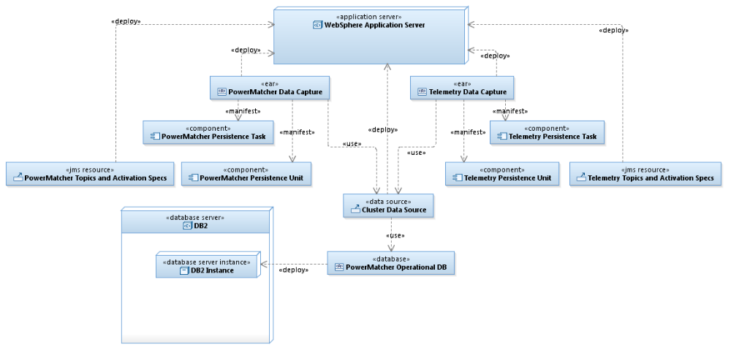
Figure 11 - Data Collection deployment

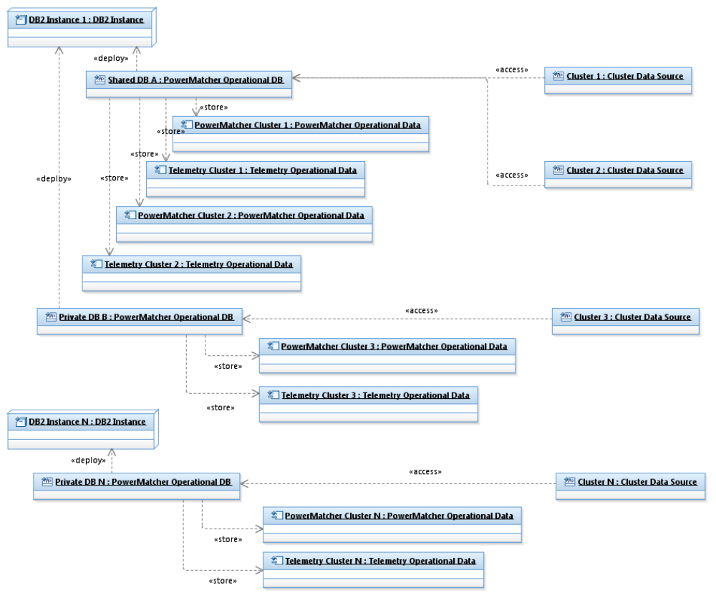
Figure 12 - Data Collection deployment example
The Data Collection deployment example shows how PowerMatcher and Telemetry data can be collected in either shared databases for multiple clusters, or a separate database per cluster.

Business Intelligence subsystem

Business Intelligence subsystem component model
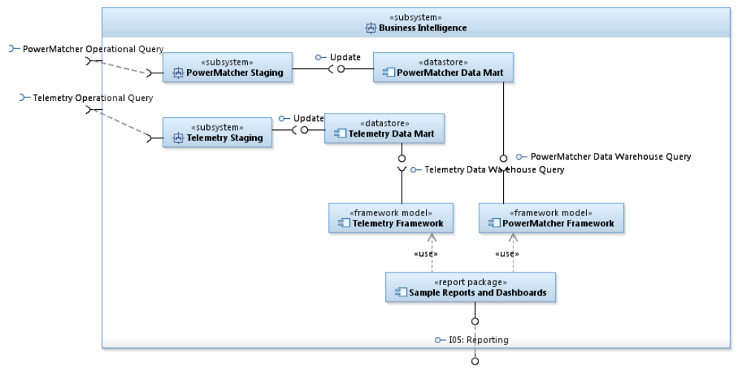
Figure 13 - Business Intelligence subsystem
The Business Intelligence subsystem is a BI solution built with IBM Cognos Business Intelligence that provides PowerMatcher and Telemetry reporting on a data warehouse. The Data Staging operations are implemented as Cognos Data Manager ETL (Extract, Transform and Load) jobs. The BI subsystem is implemented in the following components.

- Powermatcher Data Mart datastore – the data warehouse database schema for PowerMatcher logging events.
- Telemetry Data Mart datastore – the data warehouse database schema for Telemetry events.
- Powermatcher Data Staging subsystem – the ETL job for processing PowerMatcher logging events.
- Telemetry Data Staging subsystem – the ETL job for processing PowerMatcher Telemetry events.
- Powermatcher Framework component – the reporting framework for report development for PowerMatcher logging events.
- Telemetry Framework component – the reporting framework for report development for Telemetry logging events.
- Sample Reports and Dashboard package – a limited number of basic Cognos reports using the above frameworks.

Business Intelligence subsystem deployment model
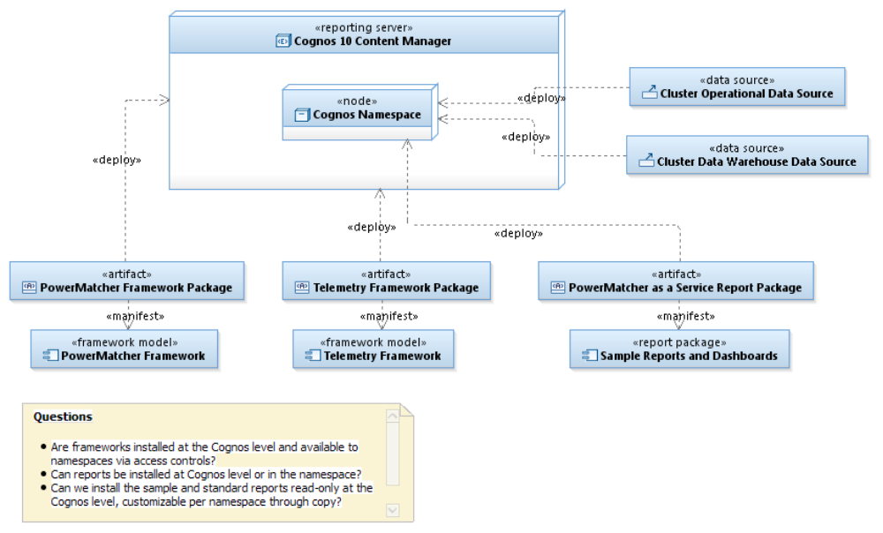
Figure 14 - Content Manager deployment

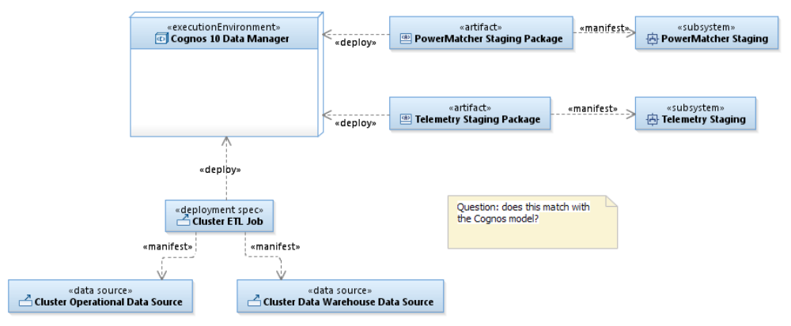
Figure 15 - Data Manager deployment

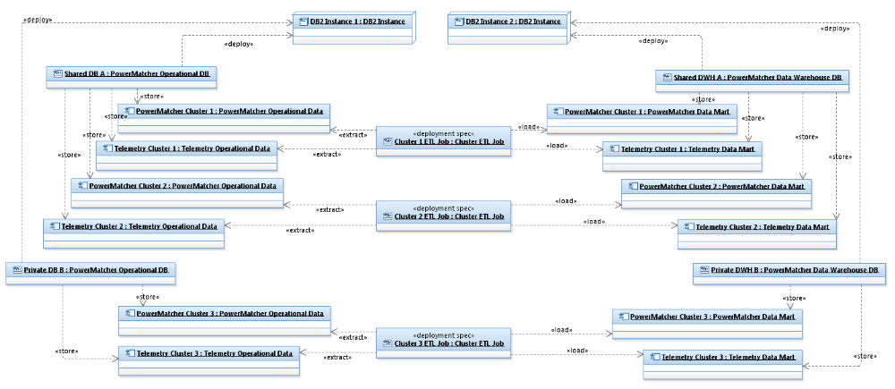
Figure 16 - Data Manager deployment example

Provisioning subsystem

Provisioning subsystem component model
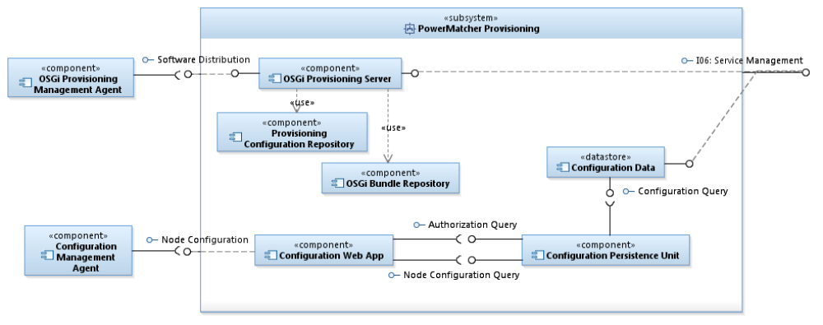
Figure 17 - Provisioning subsystem
The Provisioning subsystem is responsible for provisioning of the software and configuration to the PowerMatcher OSGi runtimes. The configuration defines the agents and properties that make up each PowerMatcher cluster, and how these agents are deployed over the distributed PowerMatcher runtimes.

Configuration Data datastore
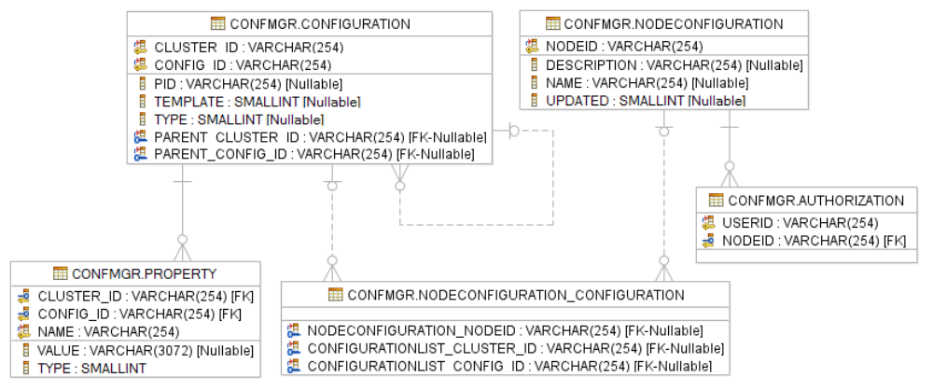
Figure 18 - Configuration Data Model

CONFMGR.Configuration table
A Configuration defines the configuration properties for a concrete configuration or a template configuration for a managed service or managed service factory. Configurations are organized in a tree with groups as nodes and managed service or managed service factory configurations as leafs. Configuration properties are inherited down the tree from groups and templates.
Column | Description
CLUSTER_ID | The cluster or namespace that the configuration element belongs to.
CONFIG_ID | The ID of this configuration element.  The configuation ID is unique within the cluster.
PID | The persistent identifier for the configuration for the managed service or managed service factory.
TEMPLATE | Boolean that indicates if this is a configuration template or not.
TYPE | Configuration type, factory=0, singleton=1, group=2
PARENT_CLUSTER_ID | The cluster ID of the parent of this configuration.
PARENT_CONFIG_ID | The configuration of the parent of this configuration.
Table 27 - CONFMGR.Configuration table

CONFMGR.Property table
A types Configuration Property of a Configuration element.
Column | Description
CLUSTER_ID | The cluster or namespace of the configuration element this property belongs to.
CONFIG_ID | The ID of the configuration element this property belongs to.
NAME | The name the configuration property.
VALUE | The value of the configuration property, represented as a string.
TYPE | The Java type of the property, String=0, Boolean=1, Integer=2, Float=3, Double=4, Long=5, Short=6
Table 28 - CONFMGR.Property table

CONFMGR.NodeConfiguration
Nodes define the runtime subsystems that can be configured.
Column | Description
NODEID | The ID of the node that is the target of configuration.
DESCRIPTION | Description of the node.
NAME | Name of the node.
UPDATED | Boolean flag that indicates of the configuration for this node has been updated (for future use, can be used to send configuration update trigger)
Table 29 - CONFMGR.NodeConfiguration table

CONFMGR.NodeConfiguration_Configuration table
Link table to assign Configuration element with its children to Nodes.
Column | Description
NODECONFIGURATION_NODEID | The ID of the node component that the configuration item is assigned to.
CONFIGURATIONLIST_CLUSTER_ID | The cluster or namespace of the configuration element that is assigned to the node.
CONFIGURATIONLIST_CONFIG_ID | The ID of the configuration element the configuration element that is assigned to the node.
Table 30 - CONFMGR.NodeConfiguration_Configuration table

CONFMGR.Authorization table
User authorizations to retrieve node configurations.
Column | Description
USERID | Authenticated user id that is allowed to access the configuration for a node.
NODEID | The ID of the node component that is the target of configuration.
Table 31 - CONFMGR.Authorization table

Configuration Persistence Unit component
The Configuration Persistence Unit is the Java EE Java Persistence Architecture component that provides access to the configuration information in the configuration database.
Configuration Data is currently loaded and updated via the command line interface of the database. There is no support

Configuration Web Application component
The Configuration Web Application provides the machine-to-machine HTTP interface for the PowerMatcher runtime node to retrieve the (updated) configuration XML for each runtime node at a regular interval or when triggered.

The Web Application also implements a web form to retrieve the configuration for each runtime node for manual inspection by the system operator and to allow the operator to trigger a runtime node to retrieve its updated configuration.

OSGi Provisioning Server and Repository components
The OSGi Provisioning Server provides the provisioning of features containing OSGi bundles to the PowerMatcher runtime. The OSGi Provisioning Server is a deployment of Apace ACE.

Provisioning subsystem deployment model
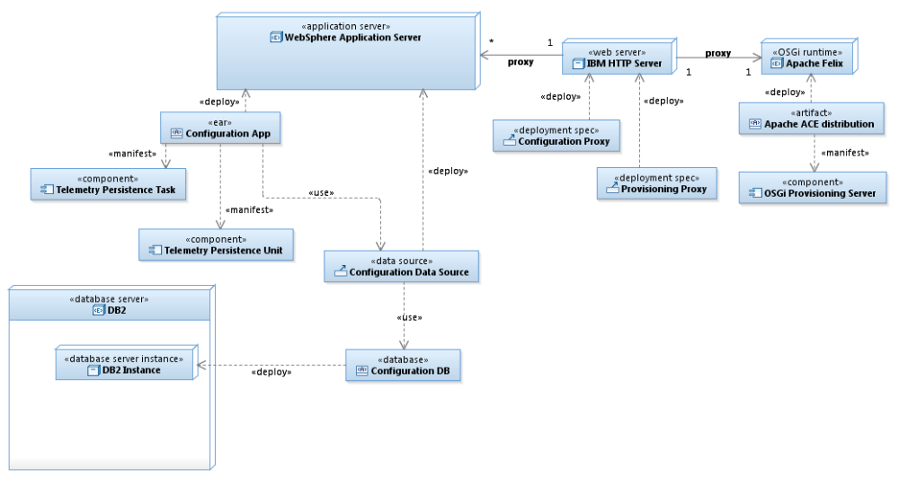
Figure 19 - Provisioning deployment
Operational Model

Distributed deployment topology

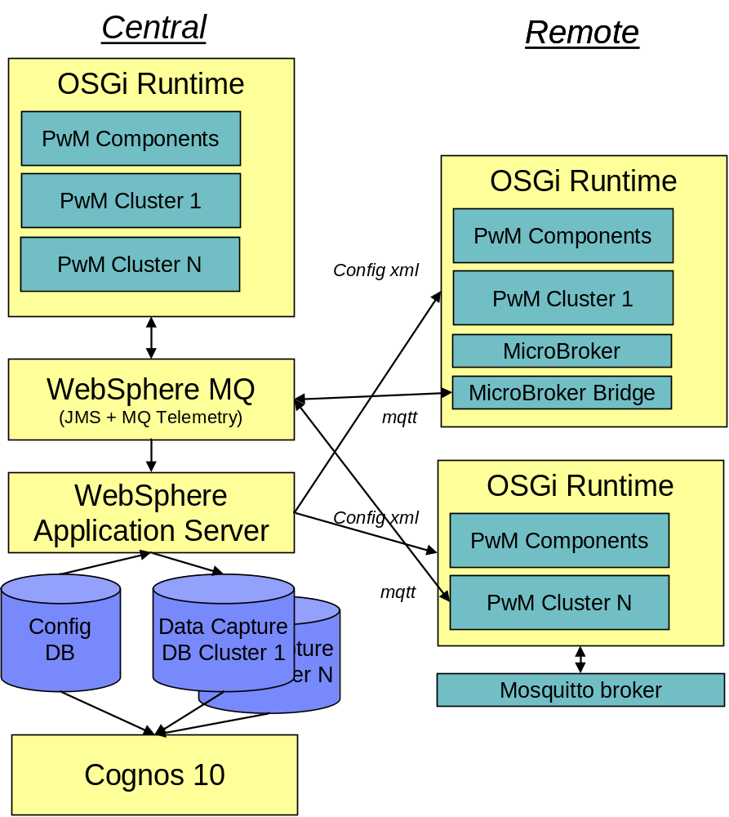
Figure 20 - Distributed Deployment Topology

Test deployment topology
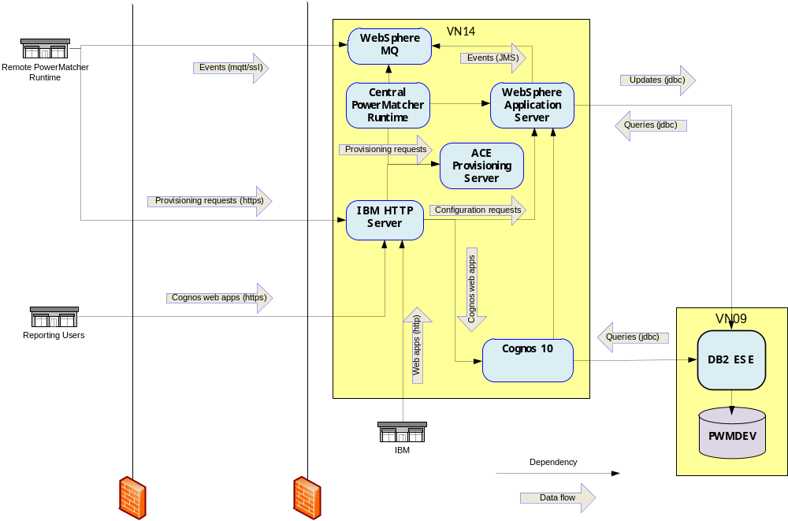
Figure 21 - Test Deployment Topology
For Matrix V a deployment is created on the test environment of the IBM Smarter Energy Platform, in combination with the deployment of a remote PowerMatcher runtime on the server in the Matrix V building. This configuration serves as the test and demonstration environment for PowerMatcher as a Service.
- References

 | IBM WebSphere MQ Information Center, section: “Developing applications for WebSphere MQ Telemetry”,  http://publib.boulder.ibm.com/infocenter/wmqv7/v7r1/topic/com.ibm.mq.doc/tt60000_.htm | N/A

See http://mqtt.org for more information on the open standard MQ Telemetry protocol.

